Altrusa of San Antonio Texas, Inc.
Organized December 15, 1922
Organized by: National Organizer Patty Garnett

Organized September 15, 1928 Chartered January 1930
Organized by: National Organizer Elizabeth Gardner
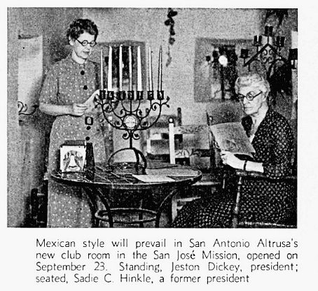
Originally organized on December 15, 1922, San Antonio became one of the first clubs to join forces with the National Association of Altrusa Clubs. Within the year, the club withdrew prior to reaching charter strength. One of the original members, Sadie C. Hinkle, refused to give up on establishing a women’s service organization in San Antonio. On September 15, 1928, Elizabeth Gardner, National Organizer, traveled from Austin to hold the next organizational meeting. Mrs. Elizabeth Forrest, Superintendent of the Bexar County School for Girls was sworn in as the first president. She was joined by Mrs. Mattie Walthall Lemon, active vice president of the Walthall Music Company as secretary. Mrs. Martha P. Roberson, part owner and manager of the Medical and Surgical Hospital was named the Executive Committee Woman. The club chartered in January 1930 with 25 charter members: including Miss Sadie C. Hinkle from the original organized club.

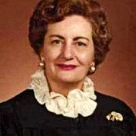
San Antonio Altrusans have always been leaders within their chosen professions, in our community, and within the club. The list of renowned businesswomen, attorneys, physicians, scientists, and educators is long and impressive. Members have always been active in local club leadership and served in numerous capacities at the state and District levels. Two members have served as District Nine governors. Carol Haberman from 1968 to 1970 and Sylvia Zamora from 2015 to 2017.
Carol Haberman
1968 - 1970

ASTRA
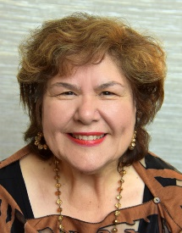
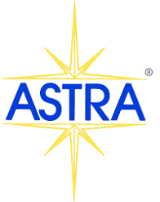
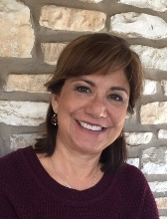
Since 2009, Altrusa San Antonio has developed and supported five ASTRA clubs. The inaugural ASTRA club was chartered at Wallace B. Jefferson Middle School with 33 ASTRANS. Unable to continue after the Teacher/Mentor departed, Altrusans established a club in the KIPP public charter school system. This continued until the COVID shutdown. Since Altrusans are known for their perseverance, a new ASTRA club was formed in 2022. This was the first community-wide ASTRA club within the District. San Antonio Altrusans are dedicated to mentoring children to identify and develop their abilities, encourage service to their communities, promote training in leadership skills and potential, encourage responsibility for themselves and others, and achieve success. Due to numerous years of tremendous effort and tireless leadership of the club’s ASTRA programs, the club’s ASTRA scholarship was renamed the Rose Strawn Scholarship.
Sylvia Zamora
2015- 2017
Rose Strawn

Service
Always dedicated to service, Altrusans continue to support a wide variety of needs throughout the San Antonio community. Throughout the club’s history, numerous organizations and groups have been served. Consistently in the forefront is service to children with the development of a child day care in the 1930s, providing much-needed supplies and donations to Child Advocates of San Antonio, Salvation Army Auxiliary, Bexar County Parole Board, several children’s shelters, Bexar County Child Welfare Board, Bexar County Child Protective Services and San Antonio Threads. Coming to the aid of women, Altrusans donated and supported Bexar County Women’s Shelter, the Battered Women’s Shelter, Guadalupe Valley Family Violence Shelter, and joined volunteers across the world at Days for Girls. Serving the elderly meant visits to nursing homes and senior citizen centers providing needed supplies, entertainment, and fellowship. Those with mental and physical illnesses and disabilities received support and fellowship as Altrusans visited the San Antonio State Hospital, the State Tuberculosis Hospital, and the Salvation Army Home and Hospital. Donations have been given to the Alamo Handicapped Association, San Antonio Independent Living Services, and wigs were collected for women with cancer treated at M. D. Anderson Cancer Center in Houston. Many hours have been volunteered at the San Antonio Food Bank and Habitat for Humanity. The club continues to support Soldiers’ Angels with donations and time to sort, pack, and ship comfort items to our valiant warriors. Our furry friends are not left out as Altrusans hold pet food drives, make pet beds, and donate other needed supplies.

Vocation and Literacy
Literacy is Altrusa’s cornerstone. Since 1930, over $50,000 has been awarded in scholarships and grants. Altrusans have served as tutors in the Learn to Read, Red Rover (using animal-based books to teach children empathy, recognize, share, and regulate emotions to enable positive connections with others), and Dual Language programs. San Antonio Altrusans have partnered with Texas Reads, KLRN (a PBS television station), San Antonio Symphony, Trinity University Community Orchestra, and numerous elementary and middle schools to promote education and educational programs. In 1949, Altrusans were instrumental in developing a vocational training program for practical nurses within the city’s school system. A year later, a similar program was initiated at Philips College for women of color. Between these two programs, 40 to 50 students graduated annually. Tens of thousands of books have been collected and donated to the Women’s & Children’s Resource Center, Bexar County Juvenile Center Library, Women’s Wellness programs, and countless book fairs at local area schools. Every year, Altrusans collect and donate school supplies to needy children.

